Name __________________________________________ Date ________________________________ Period ________
REVIEW: Energy
Directions: Answer each of the following questions to the best of your ability. This review, your notes and handout from class, and your homework will help you prepare for your unit test. You may answer #1-23 on this sheet. Use a separate sheet of paper for #24-25.

What type of energy transformation is Niagara Falls?

- What does the Law of Conservation of Energy say?

- Thermal energy is created when a firefighter slides down a pole. Where does this energy come from?

- When energy moves from one for to another it is said to be ____________________________.

- On a day when the air is still a windmill still possesses what type of energy? Why?

- Give an example of chemical energy.

- What is the energy associated with motion called?

- What is something that stores chemical energy?

- Why can moving water be used to produce electricity?

- When you rub your hands together on a cold day, what energy transformation is taking place?

- Give an example of something that his kinetic energy.

- What is potential energy?

- What is the type of potential energy that depends on height?
- What type of energy does a spinning turbine have?

- A tablespoon of very hot water is added to a pint of very cold water. What will happen to the temperature of the water?

- At what temperature will the water in each of these jars reach thermal equilibrium?

- If you set a bowl of hot soup on the table, what heat transfer (or transfers) will occur?

- You place ice cubes into a glass of lemonade. What happens to make the lemonade get cold?

- If you burn your hand on the handle of a hot pot, what type of heat transfer took place?

- What type of heat transfer occurs when hot water flows through cool water?

- Heat is transferred from one particle of matter to another without the movement of the matter itself in a process called __________________________________.

- The transfer of energy by electromagnetic waves is what type of heat transfer?

- What type of heat transfer is occurring in the picture below?
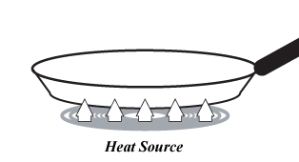
SHORT ANSWER: ANSWER ON A SEPARATE SHEET OF PAPER!!!
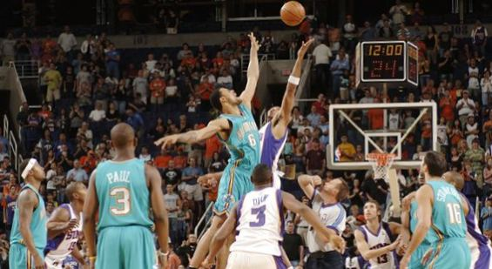
- Examine the picture of the basketball game to the right. Identify at least three forms of energy that you see in the picture. Describe where you see that form of energy and how you know it’s an example of that form of energy.

- Miss Miller wants to cook dinner for her friends, but she’s not sure what to cook. Give her one food she can cook using each of the three methods of heat transfer we discussed in class (conduction, convection, and radiation). In your response be sure to include: a) the food Miss Miller can cook; b) what method of heat transfer is used to cook that food; and c) how that method of heat transfer is being shown.

